 | REGISTRATION FORM FOR US RESIDENTS  2013 Summer National Convention  & TOS International Conference  Fill out and return to:  Registrar, Theosophical Society in America: registrar@theosophical.org  or FAX: 1-630-668-4976 or MAIL TO:  Registrar, Theosophical Society in America,  P.O. Box 270, Wheaton, IL 60187  For inquiries, call 1-800-669-1571, ext. 328 | 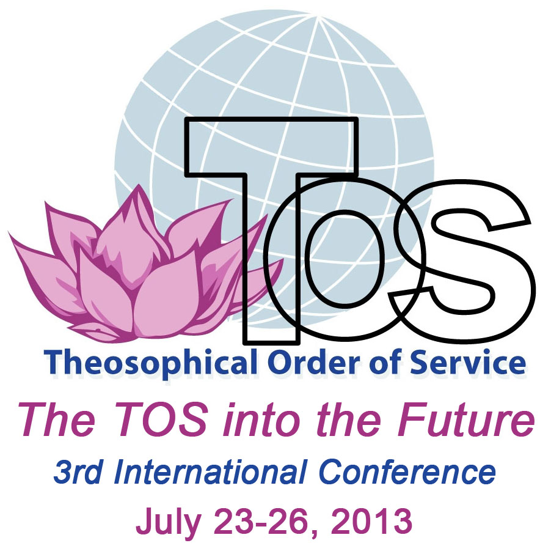
Name: ____________________________________________________________________________________________
Address: __________________________________________________________________________________________
City, State, Zip: ___________________________________ Phone: ________________ E-mail: ___________________
TSA member: Yes ______ No _______
(Note: All rates are per person)
REGISTRATION: ($30 minimum non-refundable)  Attending SNC and TOS (July 19-27, 9 days and 8 nights):  Attending SNC only (July 19-23, 5 days and 4 nights):  Attending TOS only (July 23-27, 5 days and 4 nights):  or - Single Days for SNC only:  (no daily registration for TOS Conference)  Please indicate dates attending: | $130  $100  $30  $20 full day;  $10 half day | $____________  $ ___________  $____________  $____________
TOTAL ENCLOSED | XXXXXXXX | $ _____________
On Campus Accommodations including meals: (1926 N. Main St, Wheaton, IL 60187) Very limited, 2 or 3 in a room. Please contact us first about availability before sending accommodation payment:  Attending SNC and TOS (July 19-27, 9 days and 8 nights):  Attending SNC only (July 19-23, 5 days and 4 nights): Attending TOS only (July 23-27, 5 days and 4 nights):  Single nights within conferences including meals:  Extra nights before/after conferences w/o meals:  Please indicate dates of stay: | $400  $200  $200  $50 per night  $30 per night | Mark your preferences only:  ⁪  ⁪  ⁪  # nights ____  # nights ____
Off Campus Accommodation:
Holiday Inn - Off Campus: 150 S. Gary Ave., Carol Stream, IL 60188 (2 miles from Olcott)
Phone: 1-630-665-3000 or 1-800-800-6509; www.hicarolstream.com
To reserve a room, contact Holiday Inn directly and mention this conference. Special daily rate starting at $74.95 + tax for the entire conference. (Room may be shared by up to 4 people). Free shuttle available to and from Olcott.

Meals - Vegetarian (lacto-ovo) meals are available for those staying at the Holiday Inn and commuters:
Breakfast - $5; Lunch - $7; Supper - $8.

(please turn over for more details and registration payment)

Transportation from the airport: Contact American Limousines at 630-629-0001 or 1-888-709-5466 or FAX 630-629-0002 to make a reservation at least 6 hours in advance and ask for the following business rate to the chosen location (addresses above): from O’Hare $44* including gratuity; from Midway $48* including gratuity, share ride up to 3 people and Group rates also available. Call the Limo Service toll free number after claiming your luggage to confirm your arrival. Be prepared to make a note of the limo number (which will be posted on the windshield) as well as where you should meet the limo so that you will be able to identify it when you reach the curb. *Surcharges may apply if gas prices increase.

Scholarships: A limited number of work-exchange scholarships are available for TSA members to cover the cost of registration, accommodation, and meals at Olcott during SNC only. A few partial scholarships are also available to assist with on-site expenses. All scholarship holders are required to assist by performing karma yoga, usually light kitchen duty (minimum of 2 hours/day). Contact Registrar for an application.

Refund policy: refunds will be mailed after the Convention.

- - - - - - - - - - - - - - - - - - - - - - - - - - - - - - - - - - - - - - - - - - - - - - - - - - - - - - - - - - - - - - - - - - - - - - - - - - - - - - - - - -

Registration payment must accompany the registration form.
Make checks payable to “Theosophical Society” or charge to one of the following credit cards:
Circle the card: V - MC - D Number: __________________________________________________
Expiration date: _____/_______
Three-digit verification code (located on signature line on back of card): ___________________

Signature: (Required) ________________________________________________________Date:______________

